EE4204 Lab Assignment Report
Suther David Samuel
A0182488N
AY20/21 Sem 1
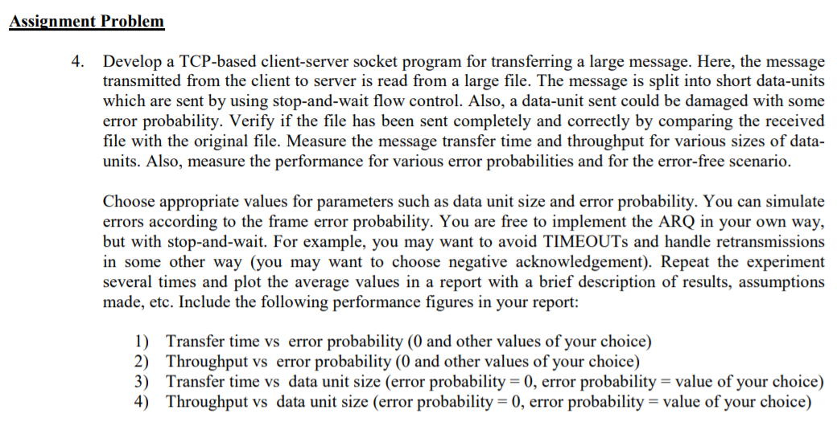

Questions 1 and 2
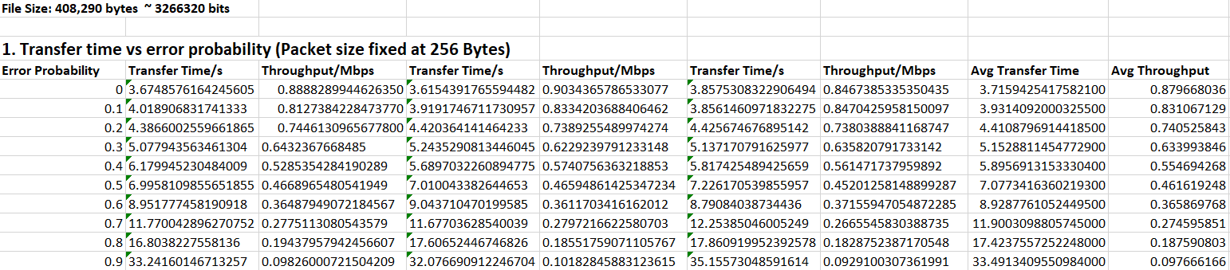

Average Transfer Time against Error Probability

Average Throughput against Error Probability

Questions 3 and 4
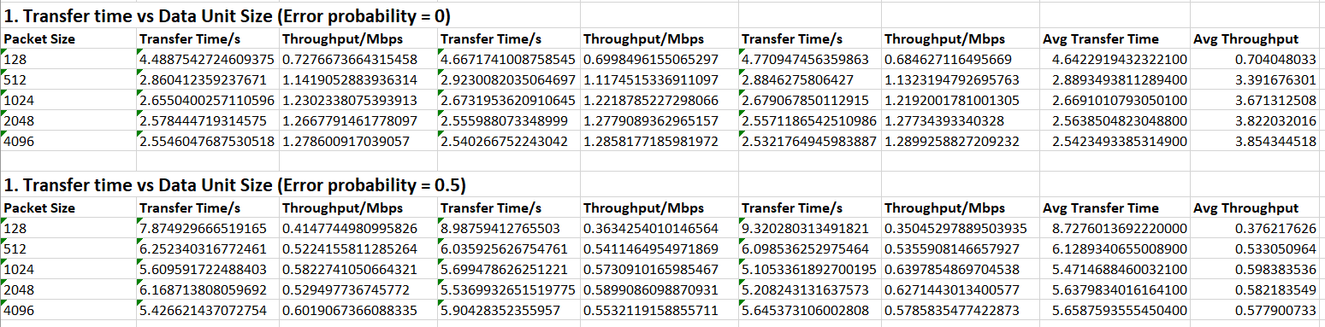

Average Transfer Time against Packet Size for Probability Error of 0

Average Transfer Time against Packet Size for Probability Error of 0.5

Average Throughput against Packet Size for Error Probability of 0

Average Throughput against Packet Size for Error Probability of 0.5

